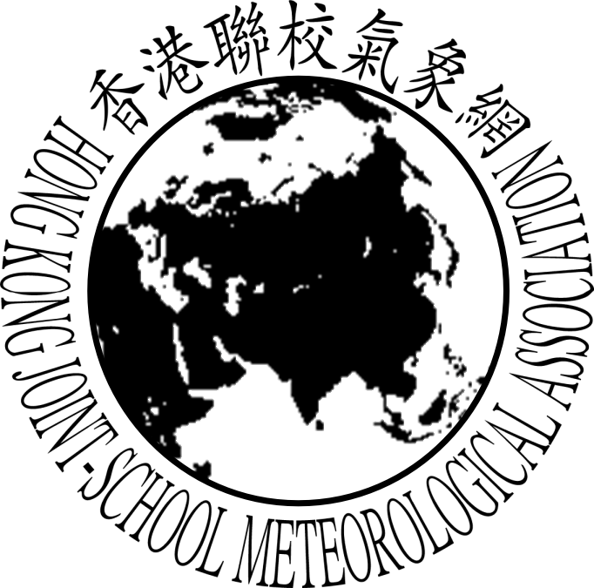
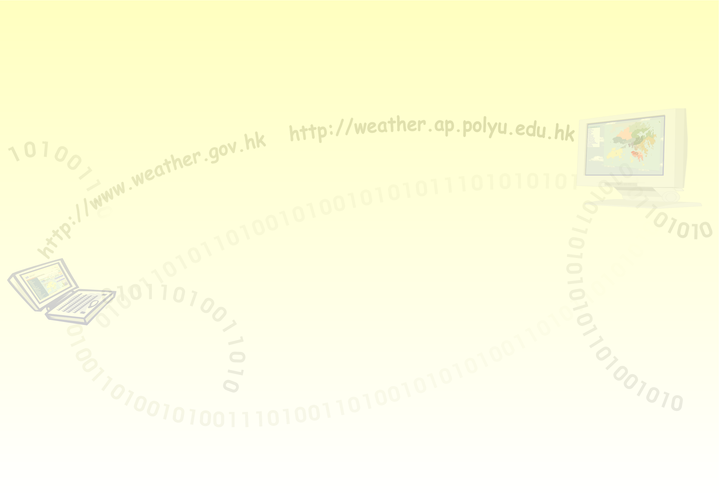
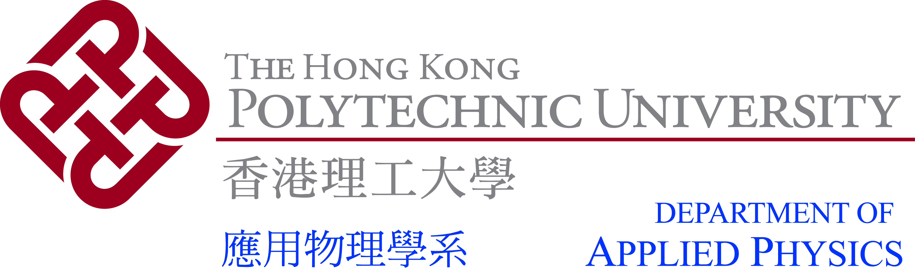


Certificate of Achievement

This is to certify that

XXX
from School

has contributed a presentation in

The 2nd Anniversary of the “Community Weather Information Network”

on 21 November 2009

Professor Helen Chan,
Chair Professor and Head of
the Department of Applied Physics,
The Hong Kong Polytechnic University
Dr. Lee Boon Ying,
Director of
the Hong Kong Observatory
Principal Kwok Chi Tai,
Chairman of
the Executive Committee of
Community Weather Information Network

