Acid Rain Measurement Guide (Author: CHENG Tak Chi)

- Setting up the rain collector
- Use a conical flask and a funnel to be the rain collector. Place it at an open area (e.g. roof) or near the automatic weather station.
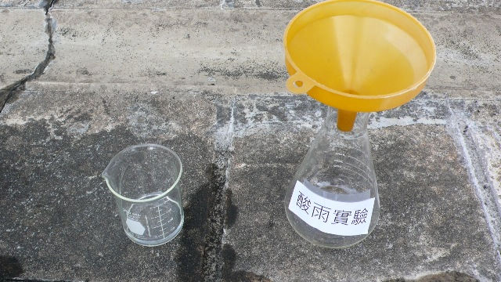

- Testing pH value of rainwater
- Keep an eye on the information from the weather station of your school or the Hong Kong Observatory. For example, if there has been over 1mm rainfall since last night, we will collect the rainwater at 7:45 a.m.

- Pour the collected rainwater into a beaker. Immerse the pH meter^{[1]} into rainwater, wait for 1 minute, and take the reading.
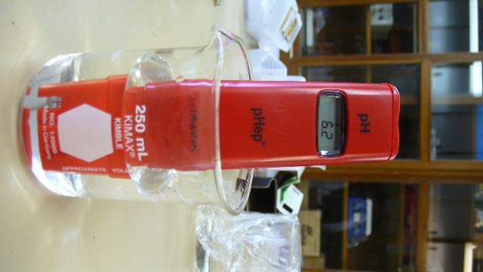

- Besides, pH paper can be used to measure the pH value of the rainwater:
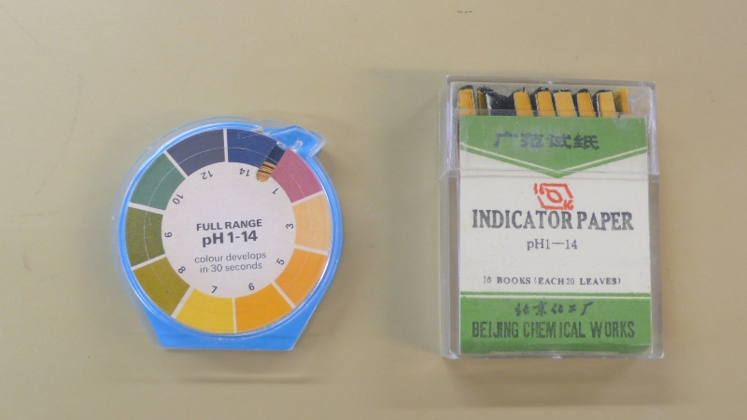

- Put the pH paper on the white tile.
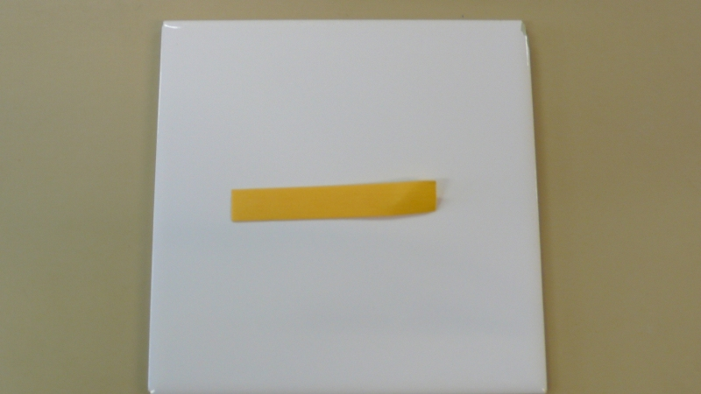

- Sample a little amount of rainwater by a dropper, and drop it onto the pH paper.
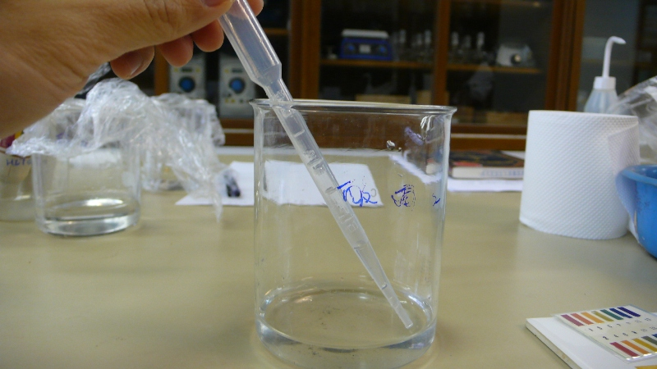
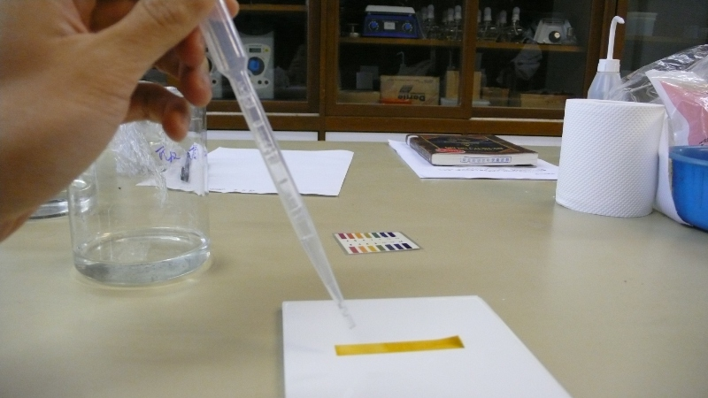

- Find out the pH value of the rainwater by comparing the pH color chart.
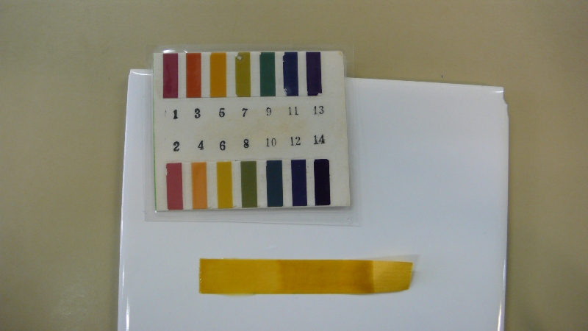
According to the pH color chart, the pH value of the rainwater should be 6.

- If the amount of rainwater is sufficient, repeat the above measurement to enhance the accuracy of the result.
- Dispose all the remaining rainwater in the conical flask.
- Record all information, including pH value of rainwater, temperature, humidity, rainfall and wind direction on that day^{[2]}.

[1]:About the pH meter
- Use the same pH meter for all measurement to prevent random error.
- Calibrate the pH meter before using at the first time. pH=4 and pH=7 buffer solution can be used as calibration standard.
- Clean the pH meter by tap water to before and after using. Soak the electrode it in storage solution or 3M potassium chloride solution after using.
[2]: Air temperature and relative humidity can be obtained from the weather station of your school, while rainfall can be acquired from the Hong Kong Observatory.
Po Leung Kuk Wu Chung College
Record of acid rain measurement (Feb 2010)
Sun | Mon | Tue | Wed | Thu | Fri | Sat
 | 1 (no rain / rain) | 2 (no rain / rain) | 3 (no rain / rain) | 4 (no rain / rain) | 5 (no rain / rain) | 6
7 | 8 (no rain / rain)  Air temperature: 17.5˚C  Diurnal minimum temperature: 17.4˚C  Relative humidity: 96.5%  Wind direction:  Rainfall: 94.1mm (7/2)  pH value: 5.9 | 9 (no rain / rain)  Air temperature: 19.7˚C  Diurnal minimum temperature: 18.8˚C  Relative humidity: 97%  Wind direction:  Rainfall:7.1mm (8/2)  pH value: 6.2 | 10 (no rain / rain) | 11 | 12 | 13
14 | 15 | 16 | 17 | 18 | 19 | 20
21 | 22 | 23 | 24 | 25 | 26 | 27
28

