Relationship between surface and air temperature
(Author: LO Cheuk Wai)
A. Objective
The difference between heat transfer (conduction, convection, radiation) and heat loss from different types of surface material would alter the relationship between surface temperature measured and air temperature (i.e. the temperature of 1.5m above the ground). Measurements and systematic analysis can be carried out to show their mutual relationship.

B. Apparatus and usage
{Use ice water and boiling water to test and calibrate the apparatus before the experiment if necessary.}
Apparatus
Type |  | Parameter to be measured | Photo and Model no. | Method of measurement
Set 1 | Portable weather meter and 1.5m tall tripod | Air temperature
Set 1 | Infrared thermometer or digital thermometer (portable) | Surface temperature
Set 2 | Mercury thermometer and 1.5m tall tripod | Air temperature
Set 2 | Mercury thermometer and Copper blocks (or box) | Surface temperature
{Either select one set of apparatus or use both and calculate the mean of each parameter measured.}
C. Procedure
Measure the surface temperature of different ground materials and the corresponding air temperature (temperature 1.5m above the ground) in the morning (07:30-09:30.), afternoon (12:00-14:00) and evening (18:00-20:00) with clear sky. Repeat the measurement four times.

Date and time of measurement
Day | Date |  | Morning (time) | Afternoon (time) |  | Evening (time)
1 | Y M D
2 | Y M D
3 | Y M D
4 | Y M D
Locations with different ground materials
Type of Ground Material |  | Photo of Ground Material |  |  | Location
Brick
Concrete
Bitumen
Grass
Water
{The ground materials above are for reference only. Other ground materials with different heat capacity and different water retention ability.}
D. Results
Record the surface temperature (T_{s}) and the corresponding air temperature (T_{a}) of different ground materials into the following table：
Type of Ground Material | Day | First day |  | Second day |  | Third day |  | Fourth day
Type of Ground Material | Time | T_{a} | T_{s} | T_{a} | T_{s} | T_{a} | T_{s} | T_{a} | T_{s}
Brick | Morning  Afternoon  Evening
Concrete | Morning  Afternoon  Evening
Bitumen | Morning  Afternoon  Evening
Grass | Morning  Afternoon  Evening
Water | Morning  Afternoon  Evening

E. Analysis
I. Graph {Sample graphs are for reference only.}
1. Brick

2. Concrete (The following sample graph is for reference only. It is extracted from final year project report “Urban Heat Island” by Ms Lai Shuk Yee of theDepartment of Applied Physics, The Hong Kong Polytechnic University)
Graph showing the relationship between air temperature and surface temperature of concrete floor.
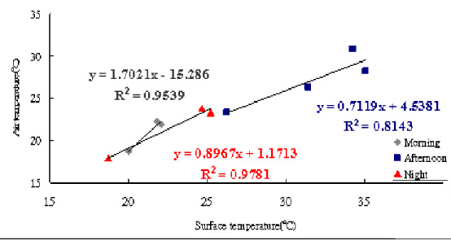

3. Bitumen

4. Grass(The following sample graph is for reference only. It is extracted from final year project report “Urban Heat Island” by Ms Lai Shuk Yee of theDepartment of Applied Physics, The Hong Kong Polytechnic University)

Graph showing the relationship between air temperature and surface temperature of grassland

5. Water

II. Formula
The relationship between air temperature and surface temperature from the figure above can be deduced. (The given equation sample is for reference only.)
Equation of air temperature deduce from surface temperature
Type of ground material | Morning | Afternoon | Evening
Brick
Concrete | y = 1.7021x - 15.286 | y = 0.7119x + 4.5381 | y = 0.8967x + 1.1713
Bitumen
Glass
Water | y = 1.0979x – 0.5956 | y = 1.0283x + 6.1561 | y = 1.0479x + 0.0934
{“y” - air temperature while “x” - surface temperature } (The equation samples above are extracted from final year project report “Urban Heat Island” by Ms Lai Shuk Yee of theDepartment of Applied Physics, The Hong Kong Polytechnic University)
{Guide student to understand that the change of slope in different equations reflects the change in relationships between surface and air temperatures of different materials.}

F. Conclusions
{Students can understand the difference between heat transfer (conduction, convection, radiation) and heat loss of different types of ground materials in different period of a day would change the relationships between the surface temperature and air temperature}
{Refer to final year project report “Urban Heat Island” sections 5.3.1 to 5.3.3 by Lai Shuk Yee of the Department of Applied Physics, the Hong Kong Polytechnic University for related conclusions.}

G. Extension ---- Using the above experimental results and the surface temperature on Earth by image from weather satellite to deduce air temperature of different areas, and to study the Urban Heat Island effect.
{This part is quite complicated, students may not understand the working principle of weather satellite. Please refer to Chapter 6 of final year project report “Urban Heat Island” by Lai shuk Yee of the Department of Applied Physics, the Hong Kong Polytechnic University.}

