Emulated radioactivity experiments

Objectives: To demonstrate the general features of nuclear radioactivity
- Background radiation
- Inverse square law
- Half life
- Randomness of emission
- Absorption (attenuation) in material

Advantages of an emulation approach
- No real source --- no problems of purchase, storage, use and transfer of radioisotopes
- Safe and no psychological panics
- Can emulate most general features of radioactivity
- Flexible (adjustable half life, background and source intensity)

Conversion
Real parts | Emulated parts
Light emitting diode (LED) | Radioisotope
Photo-sensor | Radiation counter
Light intensity | Count rate

Radioisotope

LED

Nuclear
radiation

Light

Radiation counter

Photo-sensor

android app
(to display and store data)



Bench
Basic unit for the emulated radioactivity experiments

Experiment I
Simulation of half life of radioisotope

A. Objective: To investigate exponentially decaying intensity of a light source to simulate the half life of a radioisotope

- Theory
A radioisotope contains N radioactive atoms at time t. The activity in a short time period is proportional to N, i.e.
Activity = number of emitted particles ∝ N
or Activity = k N (1)
where k is known as the decay constant.
On the other hand, the number of emitted particles in that period is equal to the number of disintegrated atoms in the same period, or –dN (Note that dN < 0).
Hence, -$\frac{dN}{dt}$= k N (2)
N = N_{o} e^{-kt} (3)
where N_{o} is the number of radioactive atoms at t = 0 s.
Half life of a radioisotope t_{1/2} is the time for N to drop to N_{o}/2. Put N = N_{o}/2 and t ₌ t_{1/2} in Eq.(3),
N_{o}/2 = N_{o} exp (-k ·t_{1/2})
ln (1/2) = -k ·t_{1/2}
t_{1/2} = ln (2)/k

From Eq. (3), ln (N) = - k·t + ln (N_{o}) (4)
The count rate, I, detected by the detector, is proportional to A, and hence is proportional to N. Hence,
ln (I) = - k·t + ln (I_{o}) (5)
The plot of ln (I) versus t is a straight line with the slope and y-intercept equal to k and ln (I_{o}), where I_{o} is the count rate detected at t = 0.

- Experiment

- Set up the experiment as shown in Fig. 1.
Emulated radioisotope
(IR-LED)

Emulated detector
(Photo-sensor)

android app
(to display and store data)

Short half-life

Bench

Fig. 1 Set up for simulating the measurement of half-life of a radioisotope

- Turn on the detector.
- Record the count rate from the background radiation I_{b} = .
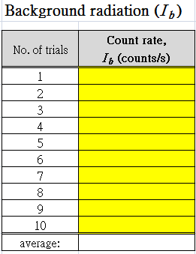
- Turn on the short half-life source.
- Record the count rate measured by the detector, I, every 5 seconds for a period of 400 seconds.
- Notice the random fluctuation of the reading.
- Subtract the background radiation from the detected count rate. Complete the following table.
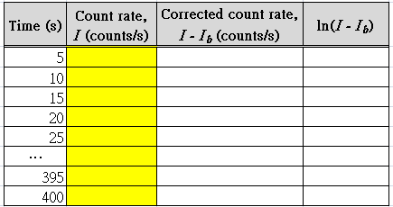
- Turn off the detector and the source.

- Analysis
Plot ln(N) against t, and hence determine k and calculate the half-life t_{1/2}.

- END -

Experiment II
Simulation of Inverse square law of radioisotope (intensity-distance dependence)

A. Objective: To investigate inverse square law of a light source for simulating the related phenomenon of a radioisotope.

B. Theory
A radioactive source emits n particles per unit time to all directions evenly. The number of particles passing through unit area on the surface of a sphere of a radius r is n' = $\frac{n}{4{πr}^{2}}$. Note that this is valid only when the absorption of radiation is negligible (like γ-radiation in air). Hence, the intensity of radiation is inversely proportional to r², or $\frac{1}{\sqrt{n'}}$= k r , with k being a constant.
This experiment uses a light emitting diode (LED) to replace the radioisotope to investigate the inverse square law. This analogy is valid because the intensity of light emitted from a light source is also proportional to 1/r², except that n' is now replaced by the intensity of light (number of photons passing through unit area of a spherical surface of a radius r), i.e.
I = $\frac{I_{o}}{4{πr}^{2}}$ (1)
or $\frac{1}{\sqrt{I}}$= k r (2)

C. Experiment
- Set up the experiment as shown in Fig. 1.

Emulated radioisotope
(IR-LED)

Emulated
detector
(Photo-sensor)

android app
(to display and store data)

r

Long half-life

Bench

Fig. 1 Set up for demonstrating the inverse square law

- Turn on the detector.
- Record the count rate from the background radiation I_{b} = .
- Turn on the long half-life source.
- Place the source at a distance of 25cm from the detector. Record the count rate I detected by the detector.
- Notice the random fluctuation of the reading.
- Move the source to approach the detector successively with a step size of 5 cm. Record the detected count rate for each distance between the source and the detector, r.
- Subtract the background radiation from the detected count rate. Complete the following table.
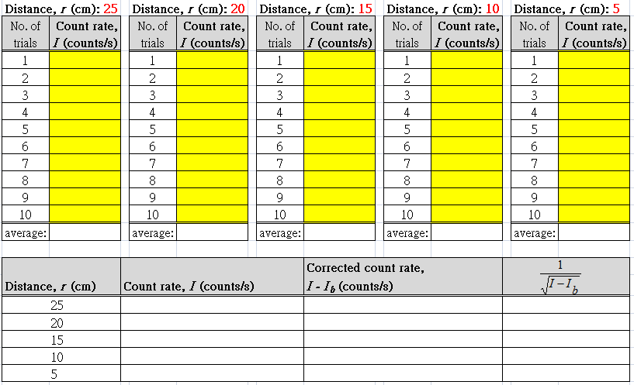
- Turn off the detector and the source.

D. Analysis and conclusion
Plot $\frac{1}{\sqrt{I−I_{b}}}$ against r, and hence verify the inverse square law as presented in Eq. (2) and comment the validity of the theory.

- END -
Experiment III
Simulation of absorption of radiation in absorber

A. Objective: To investigate the absorption of light in an optical filter to simulate absorption of radiation in a material.

B. Theory
The count rate, I, detected by the detector drops from the incident level (I_{o}) with increasing thickness, x, of the absorber, where μ is the linear attenuation coefficient (Fig. 1):
$\text{ln}\left(\frac{I_{0}}{I}\right)$ I(x) = I_{o} e ^{-μ x} (1)
= μx

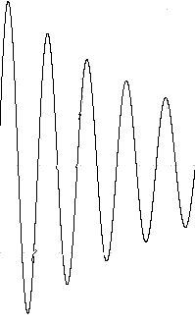
Fig. 1 Attenuation of radiation in a material of thickness x.
I_{o}
I_{o} e ^{-μ x}
x

C. Experiment
- The set up is shown in Fig. 1.
Emulated radioisotope
(IR-LED)

Emulated detector
(Photo-sensor)

Absorbing
filter

android app
(to display and store data)

Long half-life

Bench

Fig. 1 Set up for demonstrating the absorption of radiation in absorber

- Turn on the detector.
- Record the count rate from the background radiation I_{b} = .
- Turn on the long half-life source.
- Record the count rate, I_{o}, without any absorber.
- Place an absorbing between the source and the detector. Record the count rate, I, and the thickness of the absorber, x.
- Add more absorbers and repeat the measurements.
- Notice the random fluctuation of the reading.
- Subtract the background count rate from the detected one. Complete the following table.
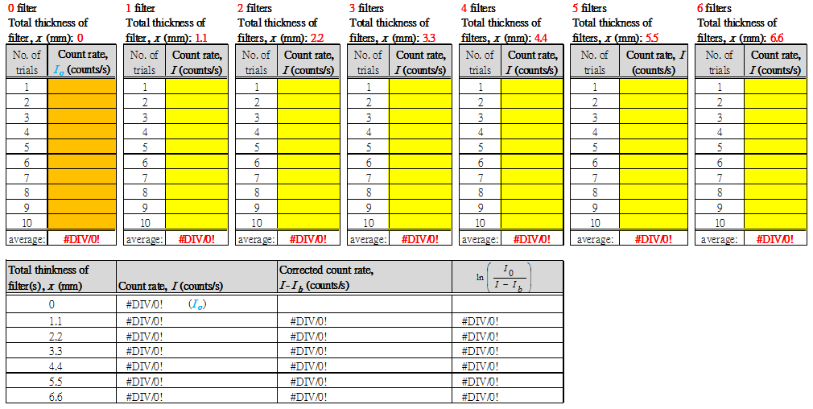
- Turn off the detector and the source.

$\text{ln}\left(\frac{I_{0}}{I−I_{b}}\right)$D. Analysis
Derive μ from the plot of versus x.
- END -
Experiment IV
Simulation of Random process of radioisotope

A. Objective: To study the random process of a light source for simulating the related phenomenon of a radioisotope.

B. Theory
Nuclear radiation is a random process. The emission rate obeys the Poisson probability distribution, however if the count-rate is large, it is very close to the normal probability distribution. In this experiment, if the count rates detected in k different time intervals are n₁, n₂, n₃, …n_{k}, … , n_{N}, with a mean of <n> = $\sum_{k=1,\text{.}\text{.}\text{.},N}{ n_{k}}$/N. They fall into M groups specified by representative count rates, m₁, m₂, m₃, …, m_{i}, … ,m_{M}. The numbers of tests showing count rates in individual groups show a normal distribution function (Fig. 1).
Number
of tests showing count rates in individual groups
m_{i}
<n>
Fig. 1 Distribution of count rate
Count rate
m_{i-1}
m_{i+1}

C. Experiment
- The set up is shown in Fig. 2.
Emulated radioisotope
(IR-LED)

Emulated detector
(Photo-sensor)

android app
(to display and store data)

Long half-life

Bench

Fig. 2 Set up for demonstrating the random process

- Turn on the detector.
- Record the count rate from the background radiation I_{b} = .
- Turn on the long half-life source.
- Record count rates in 50 time intervals (30 s each).
- Complete the following table by subtracting the background count rate to obtain the net count rates, n₁, n₂, n₃, ..., n_{N}.
Test | Total count rate | Net count rate n = Total count rate - background count rate
1
2
... | ... | ...
50

- Find the number of cases in the groups specified by respective count rates m₁, m₂, m₃, …, m_{M}, and plot a graph to illustrate the feature shown in Fig. 1.

Representative count rate | Numbers of the cases with net count rates in the groups
m₁
m₂
.... | ....
m_{M}

D. Analysis
Study the random process. Does the process obey the Poisson probability?

- END -

