Micro Urban Heat Island Effect
(Author: Matthew Wong)

- Purpose
To investigate the influences of environment on meteorological parameters around campus or nearby community.

- Procedure
- Students are divided into x (suggested to be 10) groups.
- Each group of students would be given a portable weather tracker.
- Check the status of the batteries. Replace new batteries when necessary.
- Set the date and time for synchronization.
- Set the time interval of data logging to be 5 s.
- Before start, clear data memory and then turn off the weather tracker.
- Each group goes to the respective location to be surveyed according to the schedule.
- All groups open the cover of the anemometer, and switch on their weather trackers at the same specific time.
- Collect data with the weather tracker for y (suggested to be 5) minutes. Meanwhile write down the environmental description. Then switch off the weather tracker and close the cover of the anemometer.
- Each group moves to the next location in z (suggested to be 5) minutes.
- Repeat steps 8 to 10 until finishing measurement of all locations.
- Go to ? (the specific gathering location).

- Experiment

i. Route
(Please mark on map, to be determined by school teachers, example shown below)

Map
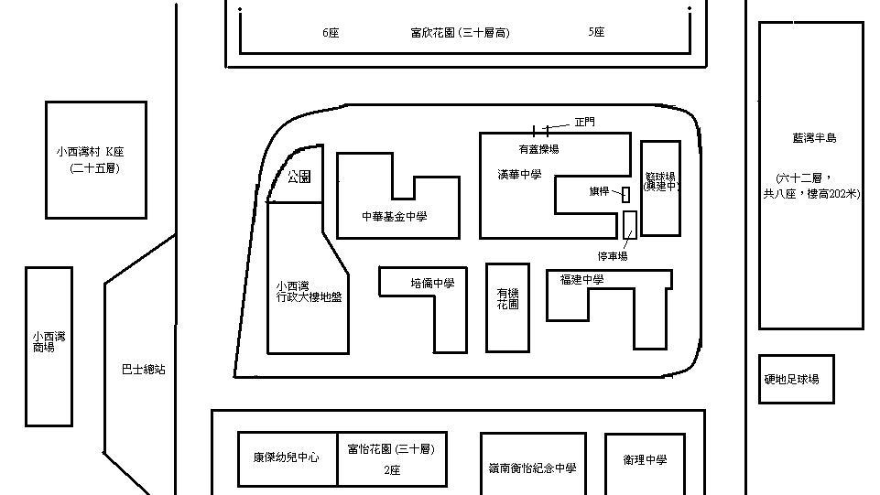
a
g
e
i
d
h
b
c
f
j

Locations
a: Flag pole
b: Car park
c: Covered playground
d: Front gate
e: Fu Yan Street
f: Park
g: Bus station
h: Fu Yi Street
i: Football playground
j: Seaside

ii. Student grouping:

iii Schedule:

- Results

Group: ______________ Weather tracker serial number: ____________

Members: ___________________________________________________________

Time | Location | Weather Information | Environmental description

